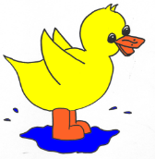
.
Puddleducks Children’s Uniform Order Form
Child’s name:___________________________
Item | Size | Quantity | Individual Price
Polo-shirt |  |  | £7.75
Sweatshirt |  |  | £9.50
Total:
(please include your payment- cash or cheque)
Size guide: 22” = 2-3 yrs
24” = 3-4 yrs
26” = 5-6 yrs
Office Use Only
Date Paid | Date Ordered | Date Received | Comments

.
Puddleducks Children’s Uniform Order Form
Child’s name:___________________________
Item | Size | Quantity | Individual Price
Polo-shirt |  |  | £7.75
Sweatshirt |  |  | £9.50
Total:
(please include your payment- cash or cheque)
Size guide: 22” = 2-3 yrs
24” = 3-4 yrs
26” = 5-6 yrs
Office Use Only
Date Paid | Date Ordered | Date Received | Comments

